## **JSPM’s**

## **Jayawantrao Sawant College Of Engineering**

## **Department Of Information Technology**

## **https://lh7-rt.googleusercontent.com/docsz/AD_4nXe4JsJEXGkcz7sCyrx9sNe-pQpG7RVOIQxf9J_VRgB2RAsd9DIfna_30vdcdtGwgpwgNLbYeuCtWxhtd9eqXTiGJ1utceqKL2GJs1D3sfXpHA3LPNub5M4F2upQpGtGJlCmsA9tnNASFAYADmWTU4g?key=l_B_EIQZwthdgpZevCRr7nVM**

## **DBMSL Mini Project Report on**

## **“Restaurant Management System”**

### **Group No – 18**

### **Mini project Group Members :**

**S1904008575 – Yogesh Popat Kemdarne**

**S1904008572 – Yash Krishnakumar Kandhare**

**S1904008564 – Mahadev Dattatray Kadam**

**S1904008613 – Umair Asad Pathan**

**Under the guidance of**

## **Prof. A.K.Gupta**

**(Academic Year 2025-26)**

|  |  |  |  |  |
| --- | --- | --- | --- | --- |
|  | **INDEX** | | |  |
| **Sr no** | **Title** | | | **Page No** |
| 1. | Abstract | | | 3 |
| 2. | Introduction | | | 4 |
| 3. | Project Specification | | | 5 |
| 3.1 | Problem Statement | | 5 |
| 3.2 | Objectives | | 5 |
| 3.3 | Project Scope | | 5 |
| 3.4 | Requirement | | 6 |
|  | 3.4.1 | Hardware Requirement | 6 |
| 3.4.2 | Software Requirement | 6 |
| 3.5 | Assumptions | | 6 |
| 4. | Data dictionary | | | 7 |
| 5. | Modules and graphical user interface (GUI) | | | 8 |
| 6. | Source Code (Sample) | | | 10 |
| 7. | Conclusion | | | 11 |

# **CHAPTER 1**

# **Abstract**

*The Restaurant Management System is designed to optimize restaurant operations, including order processing, payment transactions and staff management. By reducing manual errors and enhancing efficiency, the system improves customer satisfaction and overall business productivity. This system provides a seamless communication platform, allowing customers to place orders and make reservations online. It facilitates efficient order tracking, customer database management, and improved food service. The system includes features such as food ordering, party organization, customer and menu management, and reporting. By transitioning to a computerized solution, restaurants can streamline operations, minimize miscommunication, and enhance service delivery. The system enables restaurant staff to manage orders efficiently while providing managers with insightful reports to support decision-making. Ultimately, the Restaurant Management System ensures a faster, more organized, and customer-friendly dining experience.*

**Chapter 2**

**Introduction**

Traditional restaurant management systems often rely heavily on manual processes for handling core functions such as taking orders, managing payments, coordinating staff, and tracking inventory. While these methods have been widely used for decades, they come with several limitations that hinder the efficiency and growth of modern restaurants. Manual operations are susceptible to miscommunication between waitstaff and kitchen staff, misplaced or incorrect orders, and billing errors, all of which contribute to customer dissatisfaction. Additionally, during peak hours or busy service times, the lack of automation can lead to longer wait times, delays in service, and added pressure on employees — ultimately affecting the restaurant’s ability to deliver consistent quality.

Recognizing these challenges, this project aims to implement an Automated Restaurant Management System that leverages technology to streamline and centralize restaurant operations. This system is designed to integrate key functionalities such as order processing, table reservations, billing, and employee coordination into a single user-friendly platform. With automation, customers can place orders directly through digital menus on tablets or mobile apps, minimizing communication gaps and speeding up service. Real-time order updates ensure that kitchen staff are immediately notified of new or modified orders, reducing preparation delays and increasing kitchen efficiency.

In terms of payment processing, the RMS supports multiple secure payment options, including cash, credit/debit cards, and digital wallets, enabling faster and more flexible checkout experiences. Staff coordination is also enhanced, as managers can assign roles, monitor performance, and schedule shifts more efficiently using built-in employee management tools.

Another major advantage of the automated system is its ability to generate data-driven insights through analytics and reporting features. Managers can track sales trends, monitor inventory levels, identify best-selling items, and understand customer preferences over time. This information is vital for making informed decisions about menu planning, resource allocation, and promotional strategies.

Incorporating automation into restaurant operations not only improves service speed and accuracy but also elevates the overall customer experience. By reducing the dependency on manual processes, the system minimizes human error, enhances workflow, and allows staff to focus more on hospitality and personalized service. Ultimately, the implementation of this automated Restaurant Management System can lead to increased customer satisfaction, better resource utilization, higher productivity, and sustainable business growth in a competitive market.

# **Chapter 3**

## **PROJECT SPECIATION**

**3.1 PROBLEM STATEMENT**

Traditional restaurant management relies on manual processes for order taking, billing, and staff coordination, leading to inefficiencies, miscommunication, and delays. These challenges result in longer wait times, errors in orders, and decreased customer satisfaction. This project aims to develop an automated Restaurant Management System to streamline operations, reduce errors, enhance efficiency, and improve the overall dining experience.

**3.2 OBJECTIVES**

* Develop a comprehensive restaurant management system for order and table management.
* Ensure secure and quick payment processing.
* Maintain a structured database of customers, staff, and transactions
* Improve staff coordination and workload distribution.
* Generate reports for business insights and performance analysis.

**3.3 SCOPE**

The **Restaurant Management System** offers a range of features to enhance efficiency and customer satisfaction. It streamlines **order management** by enabling digital order placement, tracking, and processing, ensuring faster and more accurate service. The system also includes a **table reservation** feature that allows customers to book tables online, optimizing seating arrangements and reducing wait times. **Billing and payment processing** are automated, offering multiple payment options for seamless transactions and reducing manual errors. Additionally, the system facilitates **staff and customer management** by organizing employee schedules and maintaining customer data for improved service delivery. **Menu management** allows restaurants to update food items, prices, and availability effortlessly, ensuring customers have access to the latest offerings. Lastly, **reporting and analytics** provide valuable business insights, helping restaurant owners make informed decisions and optimize performance.

.

* 1. **Requirements**

|  |  |
| --- | --- |
| **Components** | **Description** |
| RAM | Recommended 4GB RAM |
| Storage | Minimum 256GB SSD |
| Internet Connection speed | 10-25 Mbps Recommended |

**3.4.1Hardware Requirement**

* + 1. **SOFTWARE REQUIREMENTS**

|  |  |
| --- | --- |
| **Components** | **Description** |
| Operating System | Windows/Linux OS |
| Database | MySQL Database |
| Programming Language | Java/Python for Backend HTML, CSS, JavaScript for Frontend |
| Payment method | Payment Gateway Integration eg. RazorPay etc |

**3.5 ASSUMPTIONS**

A Restaurant Management System where customers, waiters, chefs, and managers are the primary users. Customers can place orders and make reservations, updating table availability and kitchen workflow.Waiters take orders and serve food, ensuring smooth communication between customers and the kitchen. Chefs receive orders and prepare meals, updating order status accordingly. Managers oversee operations, manage staff, and generate reports for business insights. The system ensures efficient service, order accuracy, and secure payment processing, complying with restaurant standards and operational policies.

**Chapter 4**

**Data Dictionary**

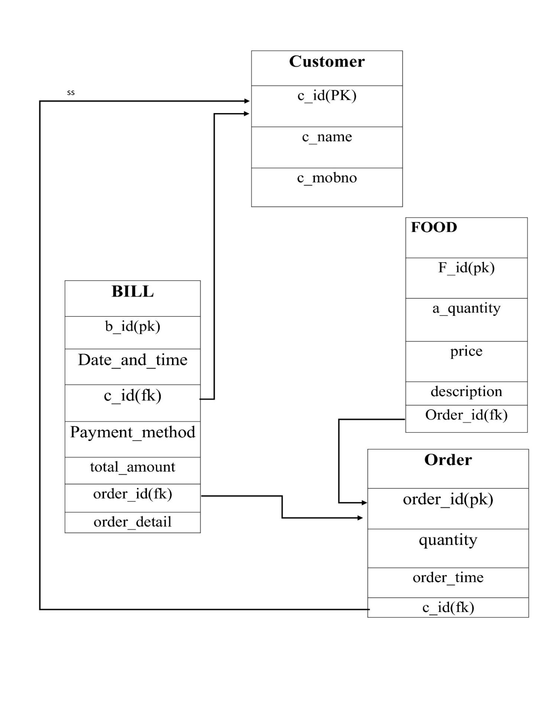

**CHAPTER 5**

**Modules and graphical user interface (GUI)**

**Modules of the System**

The Restaurant Management System is divided into several functional modules that ensure smooth operation and easy management of restaurant activities:

1. **Customer Management Module**
   * Registers and stores customer details such as name, contact number, and address.
   * Helps staff provide faster and more efficient customer service.
2. **Order Management Module0**
   * Handles all dine-in and takeaway orders.
   * Allows modification or cancellation of orders before confirmation.
3. **Food & Menu Management Module**
   * Enables addition, updation, and removal of food items.
   * Maintains real-time pricing and availability of menu items.
   * Supports digital menu display for customers via screens or mobile apps.
4. **Billing and Payment Module**
   * Automatically generates bills based on completed orders.
   * Supports multiple payment options: Cash, Card, and UPI/Online Wallets.
5. **Security & Access Control Module**
   * Role-based access for Admin & user.
   * Protects sensitive information such as login credentials and payment details.
   * Ensures data integrity and secure transactions

**Graphical User Interface (GUI)**

The GUI of the Restaurant Management System is designed to be user-friendly, intuitive, and responsive. It allows both staff and customers to interact with the system efficiently.

* Login Page: Provides secure access based on role (Admin, Customer).
* Customer Panel: Simple form-based interface for customer details and reservations.
* Order Screen: Menu displayed with food categories, search options, and “Add to Cart” functionality.
* Billing Screen: Automatically lists selected items, calculates total, applies taxes, and generates a printable bill.
* Admin Panel: Provides options for managing menu items, staff details, and generating performance reports.

**The GUI ensures:**  
✔ Easy navigation for staff and customers  
✔ Minimal training requirements  
✔ Quick access to frequently used operations  
✔ Mobile and tablet compatibility for better usability

**CHAPTER 6**

**Source Code**



**Script.js**

const express = require("express");

const mongoose = require("mongoose");

const cors = require("cors");

const app = express();

app.use(cors());

app.use(express.json());

// MongoDB connection

mongoose.connect("mongodb://127.0.0.1:27017/restaurantDB")

.then(() => console.log("✅ Connected to MongoDB"))

.catch(err => console.error(err));

// Food Schema

const foodSchema = new mongoose.Schema({

name: String,

price: Number,

category: String

});

const Food = mongoose.model("Food", foodSchema);

// API Routes

app.get("/api/foods", async (req, res) =>

{

const foods = await Food.find();

res.json(foods);

});

app.post("/api/foods", async (req, res) =>

{

const food = new Food(req.body);

await food.save();

res.json({ message: "Food added successfully!" }); });

const PORT = 3000;

app.listen(PORT, () => console.log(`🚀 Server running at [http://localhost:${PORT}`)](http://localhost:$%7bPORT%7d%60)));

**CHAPTER 7**

**Conclusion**

The Restaurant Management System is designed to streamline and automate key restaurant operations such as order management, billing and staff coordination. By reducing manual errors and enhancing efficiency, the system ensures a seamless dining experience for customers while improving business productivity. With features like real-time order tracking, automated billing, inventory management, and data analytics, the system empowers restaurant owners to make informed decisions and optimize daily operations. Additionally, multi-device compatibility and secure payment integration enhance customer convenience and service reliability. Overall, implementing this system helps restaurants increase efficiency, improve customer satisfaction, and maintain smooth operations, making it a valuable tool for modern restaurant management.